**Lab # 10**

**A Digital Lock**

CSE-308L [DIGITAL SYSTEM DESIGN LAB](https://classroom.google.com/c/NTk1NjYyOTEyNzU5)

**Name: Maaz Habib**

**Reg No: 20PWCSE1952**

**Section: C**

**Submitted to:**

**Engr. M. Usman Malik**

Department of Computer Systems Engineering

University of Engineering and Technology, Peshawar

**Objective:**

Build an electronic combination lock with reset button, two number buttons (0 and 1), and an unlock output. The combination should be “01011”

**Lab Tasks:**

Change the functionality of the lock such that it unlocks on the sequence of 11011

**Code**

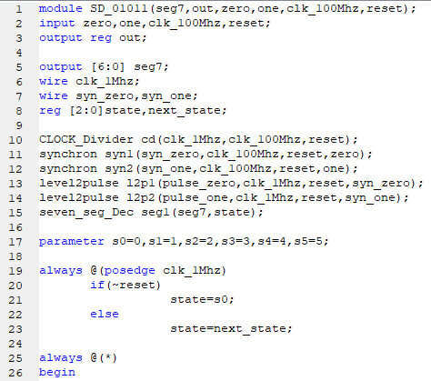

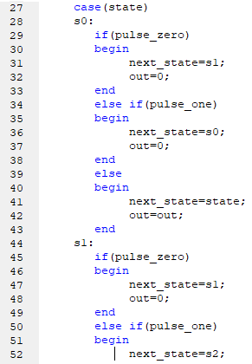

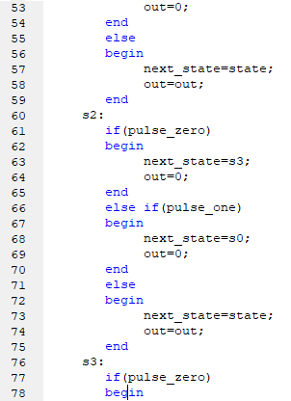

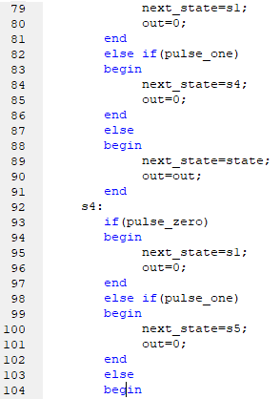

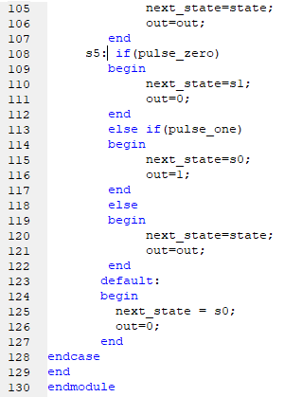

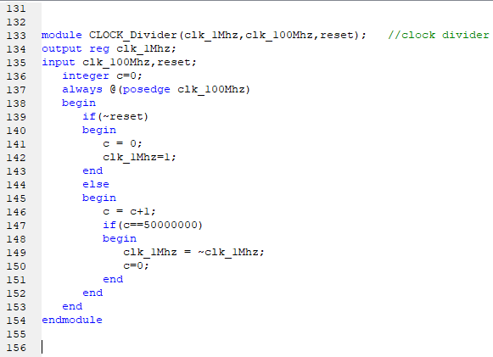

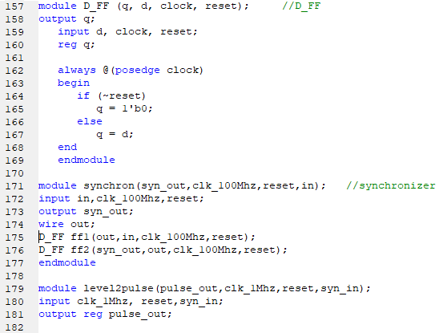

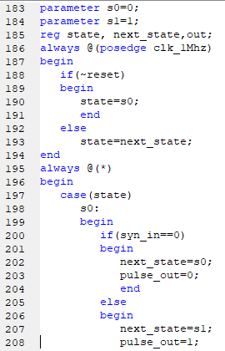

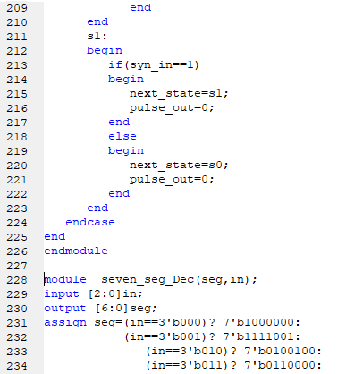

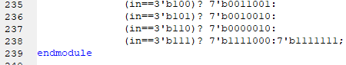

**User Constraint File(ucf)**

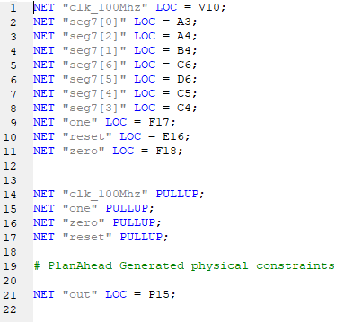

**Output:**

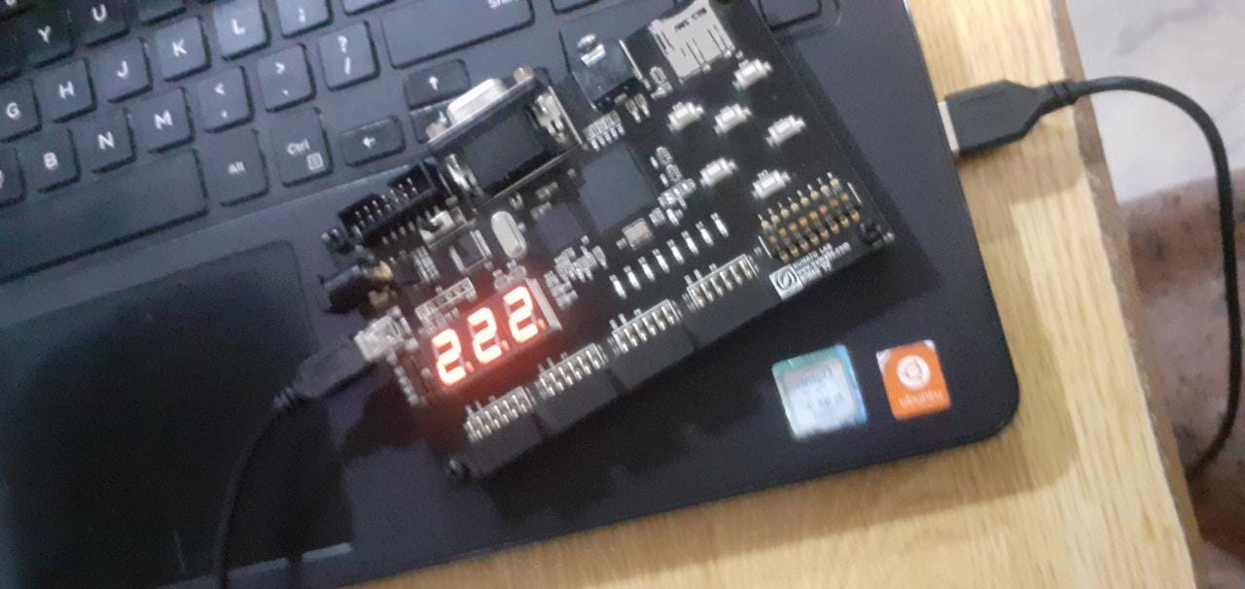

**Schematic Diagram:**

